1)Make sure you get this page after logged in as we need to create the VM’s using template.

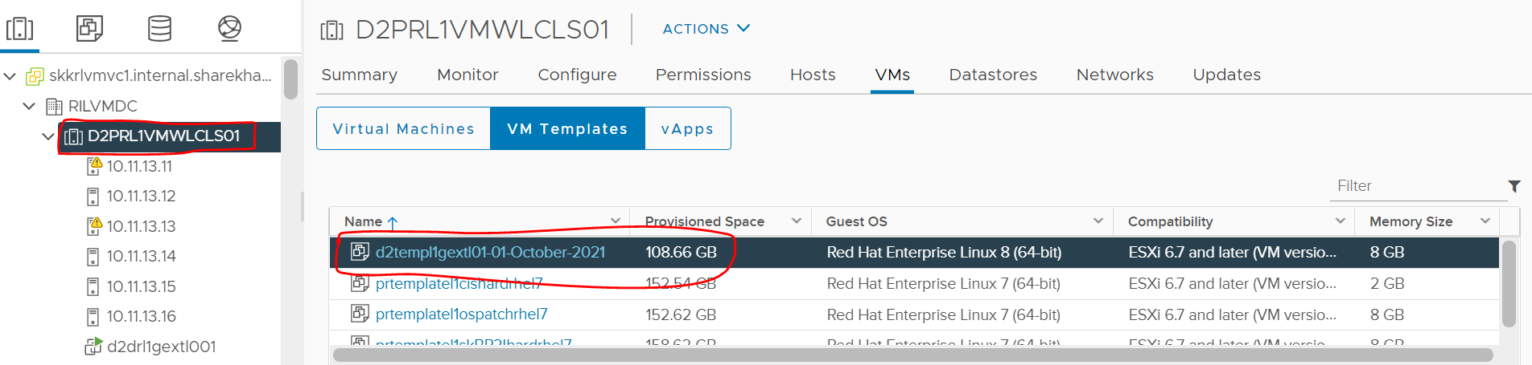

2)Now right click on the template > New VM from this template.

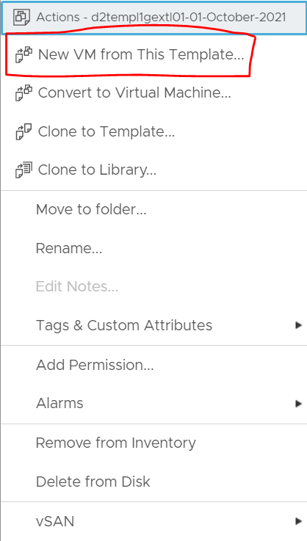

1. After clicking on New VM from this template you will get the below display to enter the VM name I.e the hostname received via mail. Click on next.

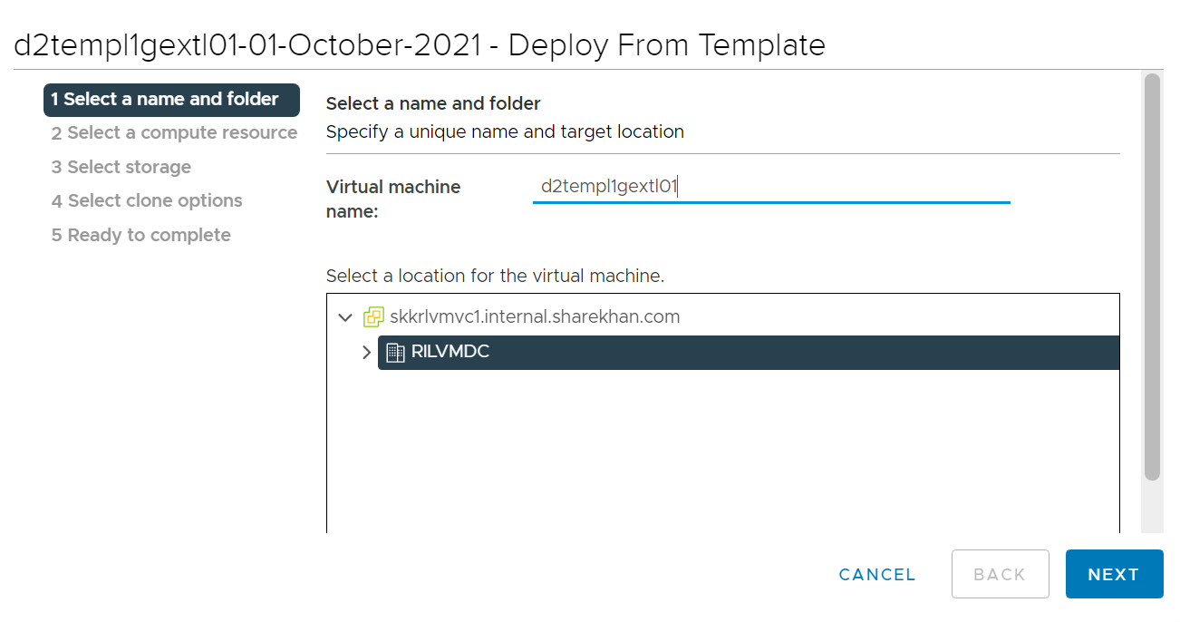

1. Now we need to select the cluster accordingly and select the node given on mail. Once node is selected click on next.

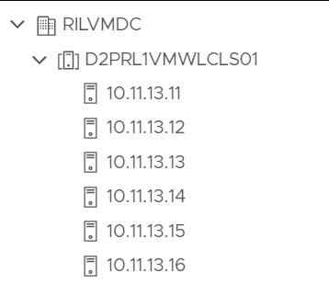 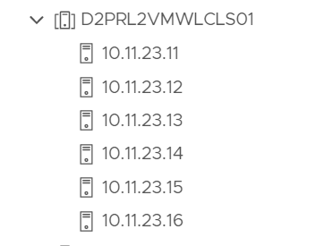

1. Now we need to select the storage as OS01 or OS02. Here we have selected OS01 which we again need to select according to the hostname. And click on next.

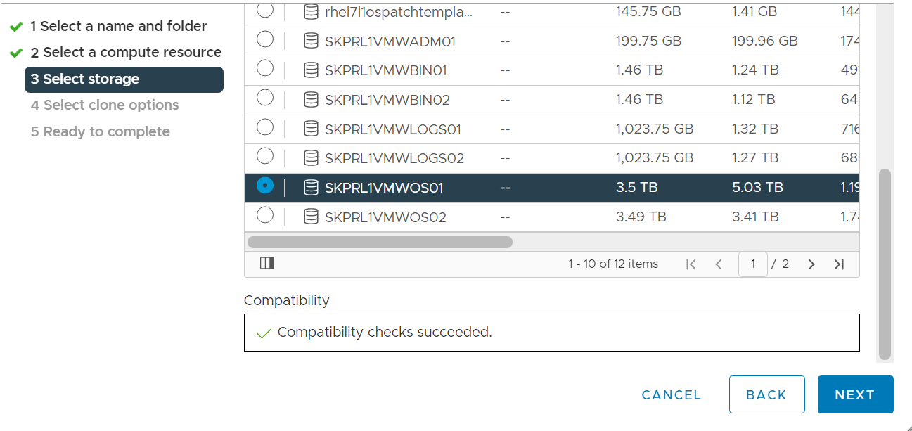

1. After selecting the disk you need to **“Select virtual disk format = Thin Provision”**.

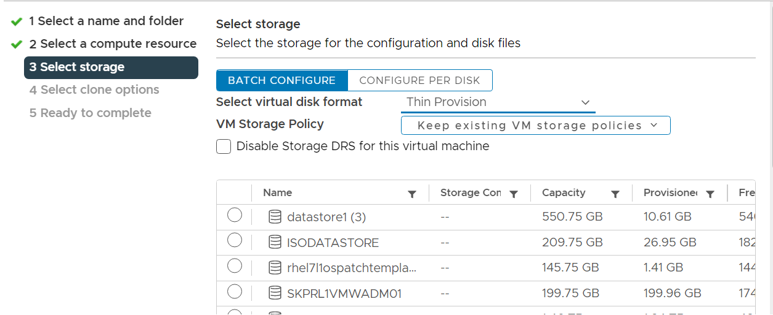

1. Here in Selecting clone options we need to click on all check boxes and click next.

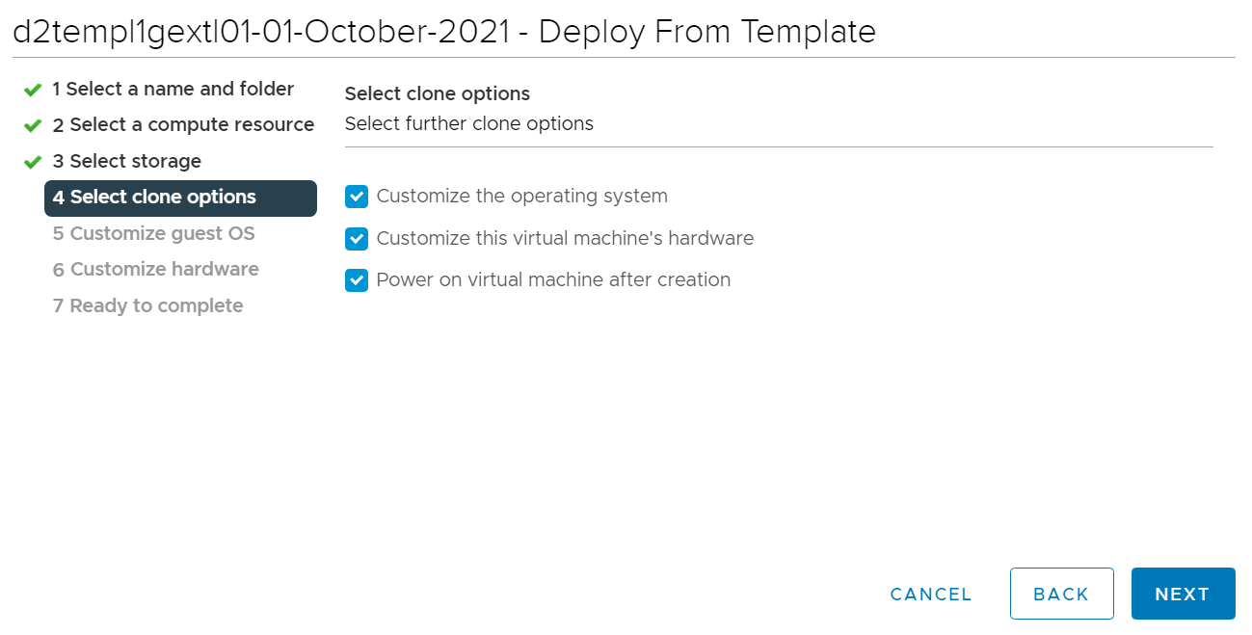

1. Now here you need to simply click on next.

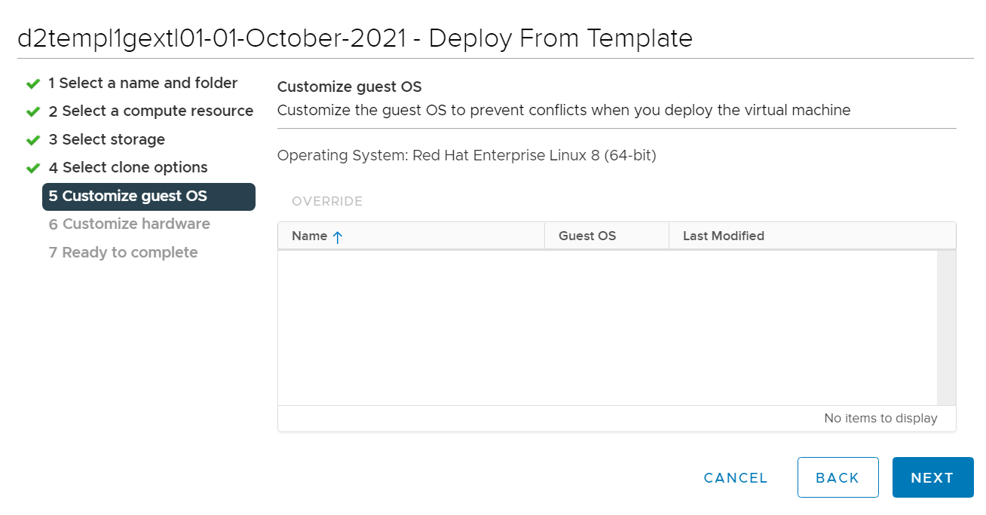

1. Here in **customize hardware** you need to select the RAM accordingly and make sure that “**Enable CPU Hot Add**” check is clicked as shown below.

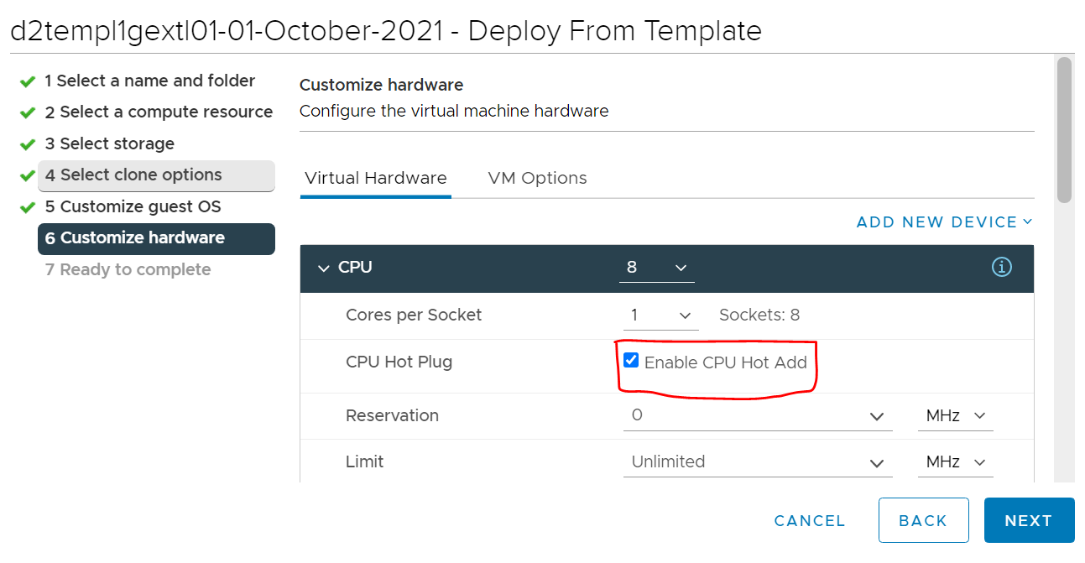

1. Next is memory which we need to apply accordingly. Also make sure you need to select “Memory Hot Plug” check box. Now select next.

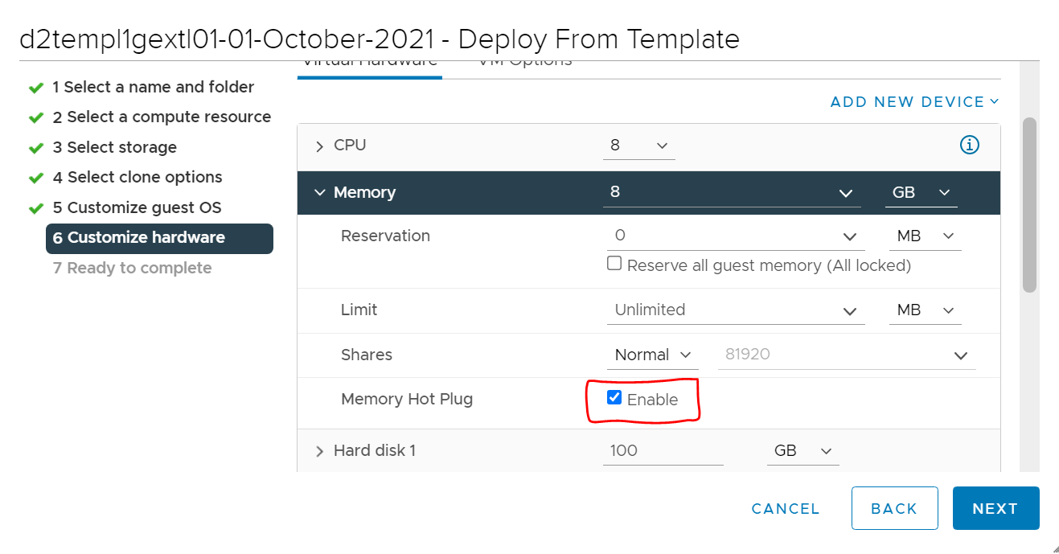

1. This is a complete summary of the VM you have created. Click on Finish to get the VM added in the list.

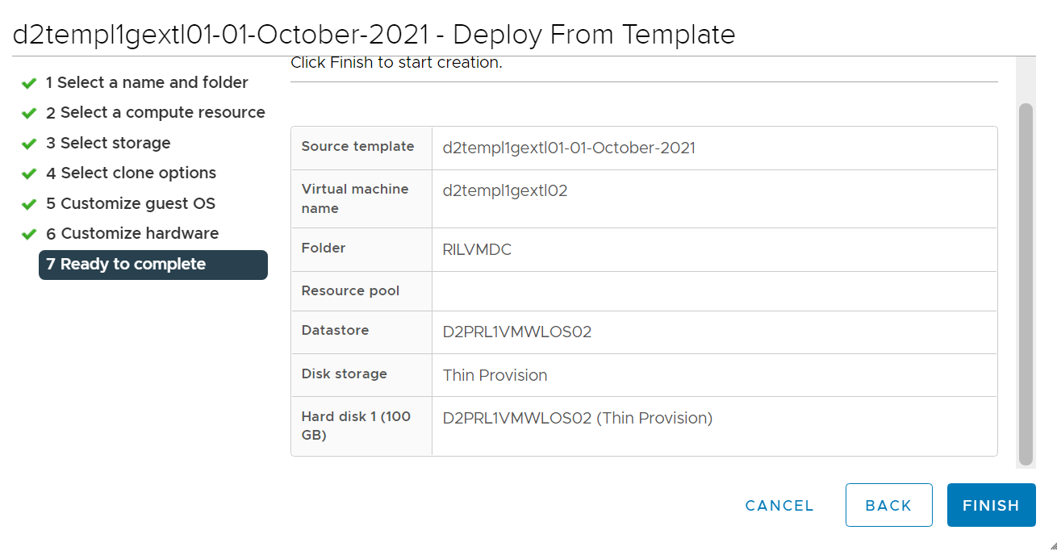

1. Now your VM is created and added in the list. Now we need to add the harddisks accordingly.So we need 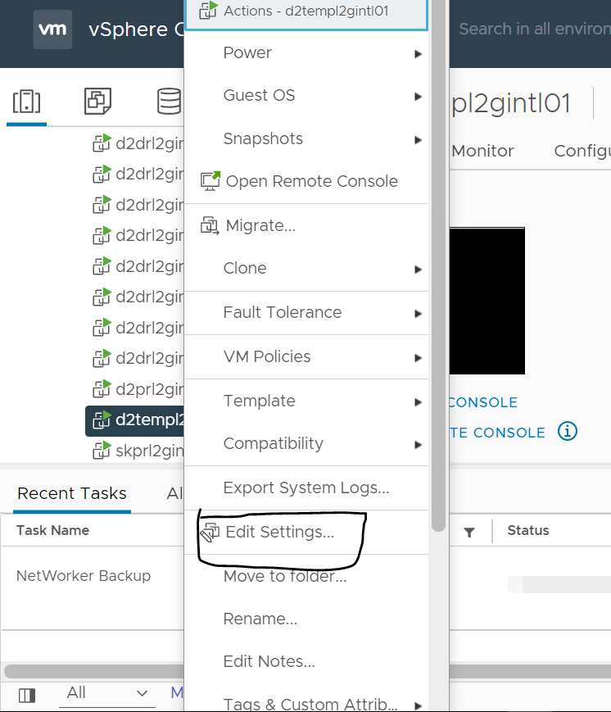to right click on the **Newly created VM > edit settings**.

13) After clicking on edit settings below window will appear. Here we need to add hard disks.To add harddisk we need to click on **“ADD NEW DEVICE”.**

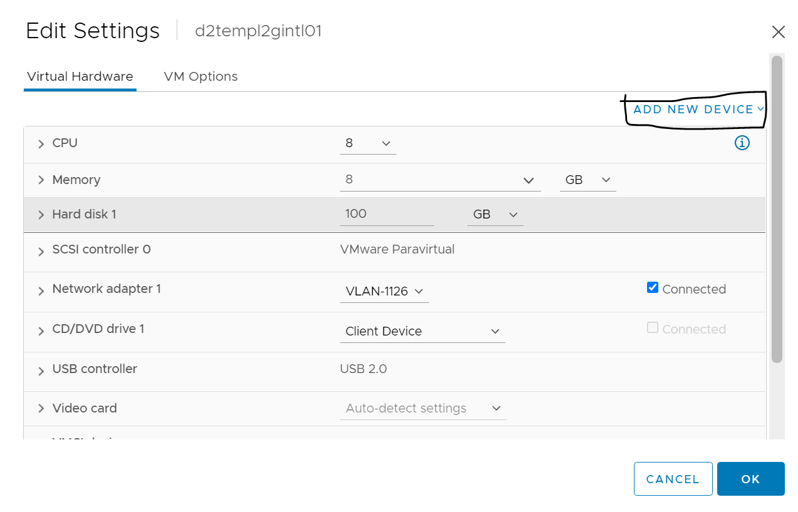

14) Below is the output and now we need to select the Harddisk option.

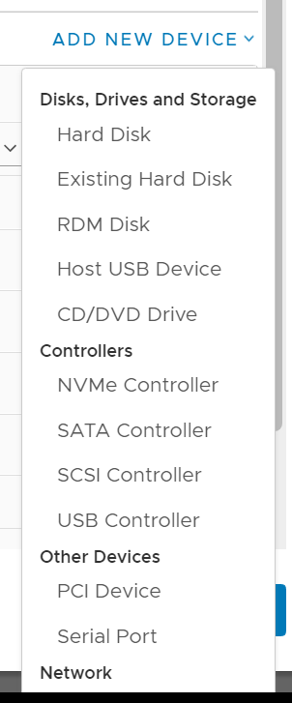

1. Once you add the harddisk it will show as below here you need to add the size. After the size is added you need to select location and disk provision

To select the location you need to click on it and select browse there you will get the option of BIN01/BIN02. You will need to select the disk as per hostname.

**NOTE- The OS,BIN,LOG must all have same numerical value throughout the disk selection**.

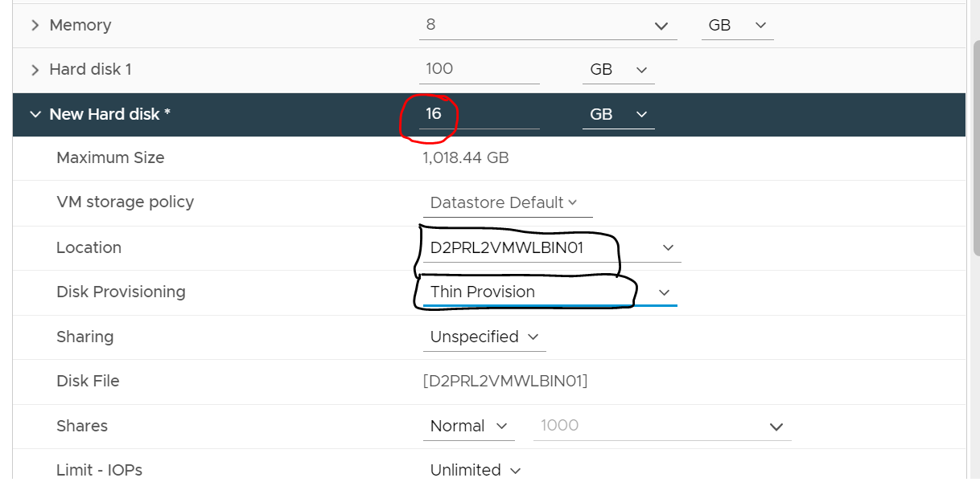

1. Now we need to add another disk to the VM. So we again click on the add new devices and select hard disk, but now we select a different location and that is LOG. With the same disk provisioning as thin provision.

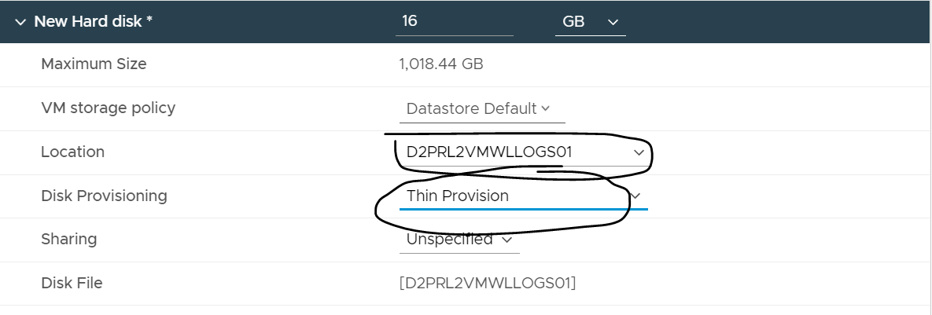

**Now your VM is ready to be logged in via username.**